Zabbix监控

监控的目的



类别

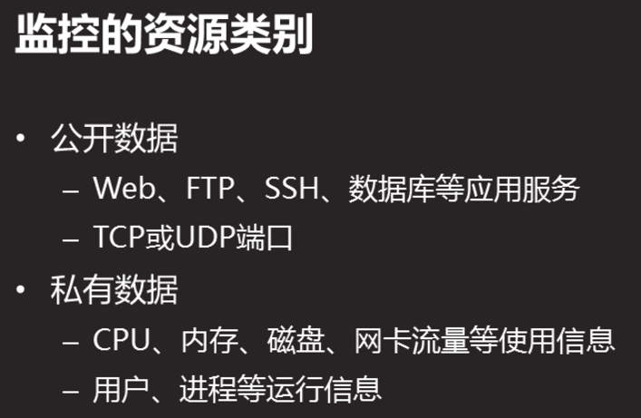

主流软件

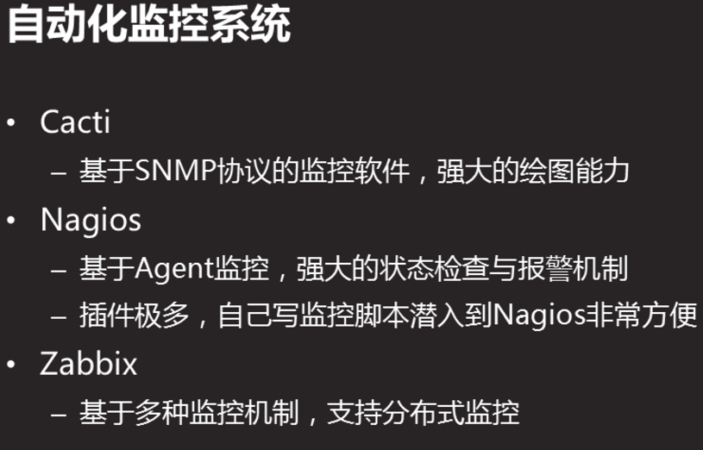

常用监控命令

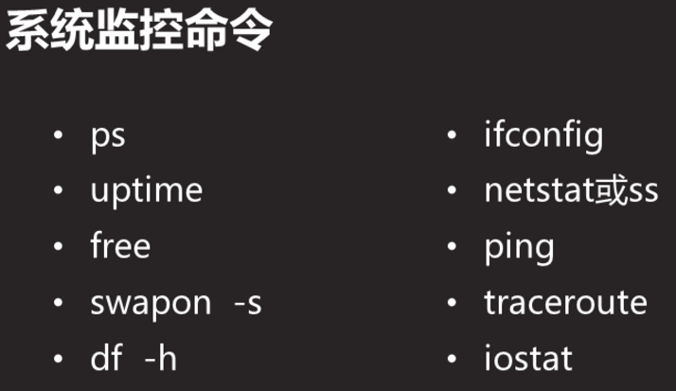

Tracetoute 跟踪路由

Iostat 磁盘的读写速度

[root@room13pc5 ~]# yum -y install sysstat

[root@room13pc5 ~]# which iostat

/bin/iostat

[root@room13pc5 ~]# iostat

Linux 3.10.0-862.el7.x86_64 (room13pc5.tedu.cn) 2019年07月24日 _x86_64_(4 CPU)

avg-cpu: %user %nice %system %iowait %steal %idle

2.46 0.03 0.92 0.85 0.00 95.75

Device: tps kB_read/s kB_wrtn/s kB_read kB_wrtn

sda 11.03 278.67 58.60 1137169 239112

Zabbix简介

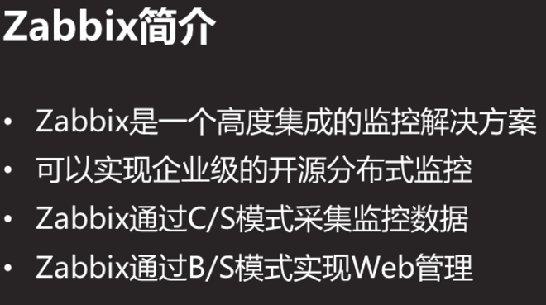

拓扑

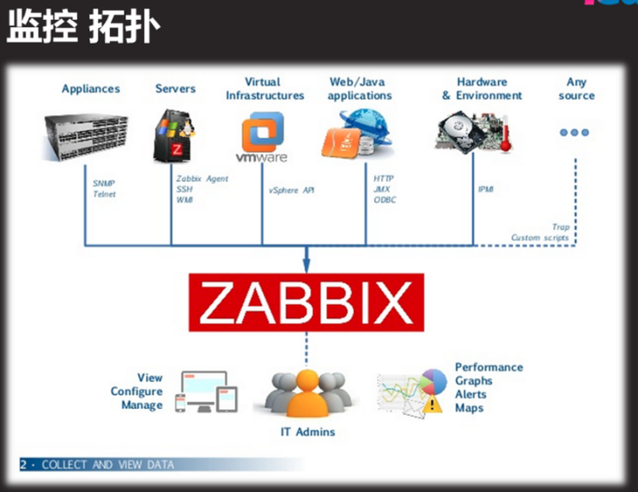

zabbix支持snmp网络协议设备/windows设备/虚拟/各种服务/硬件

部署监控服务器

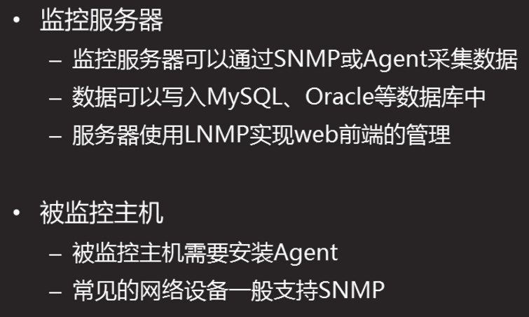

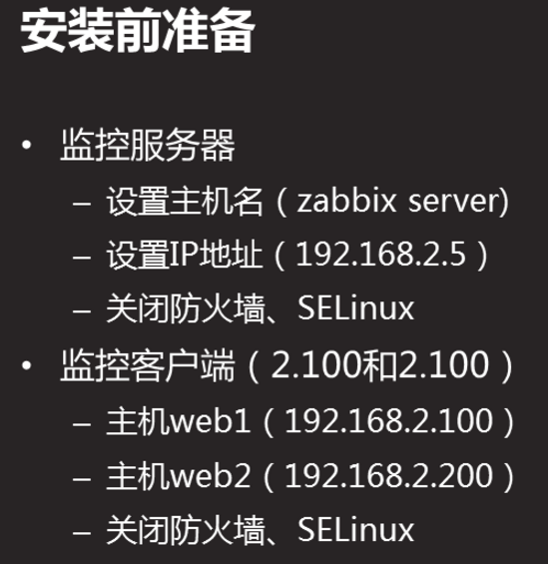

部署运行环境LNMP

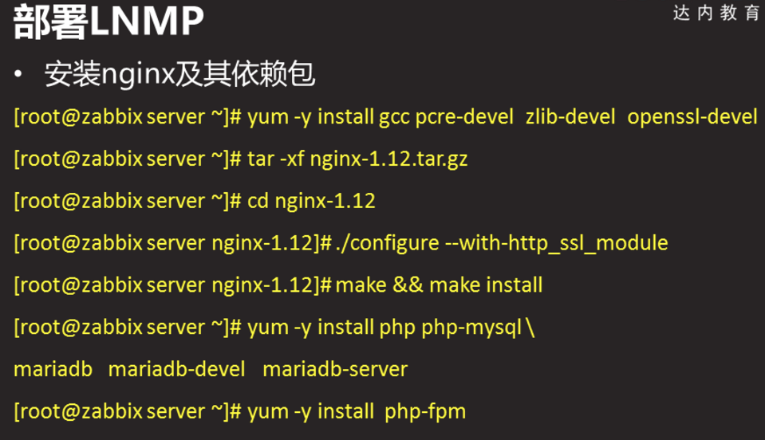

[root@zabbixserver nginx-1.12.2]# yum -y install gcc pcre-devel zlib-devel openssl-devel

[root@zabbixserver nginx-1.12.2]# tar -xf nginx-1.12.2.tar

[root@zabbixserver nginx-1.12.2]# cd nginx-1.12.2/

[root@zabbixserver nginx-1.12.2]# ./configure --with-http_ssl_module

[root@zabbixserver nginx-1.12.2]# make && make install

[root@zabbixserver nginx-1.12.2]# yum -y install mariadb mariadb-devel mariadb-server

[root@zabbixserver nginx-1.12.2]# yum -y install php php-mysql php-fpm

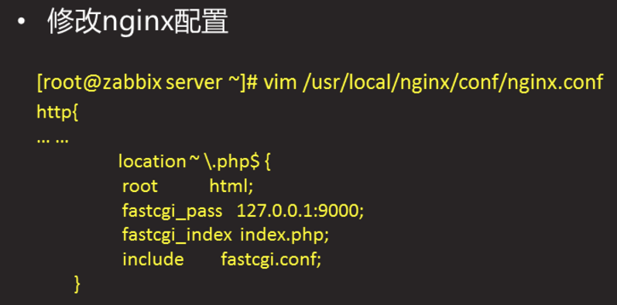

修改nginx配置

[root@zabbixserver nginx-1.12.2]# vim /usr/local/nginx/conf/nginx.conf

location ~ \.php$ {

root html;

fastcgi_pass 127.0.0.1:9000;

fastcgi_index index.php;

include fastcgi.conf;

}

[root@zabbixserver nginx-1.12.2]# ln -s /usr/local/nginx/sbin/nginx /sbin/nginx

启动服务

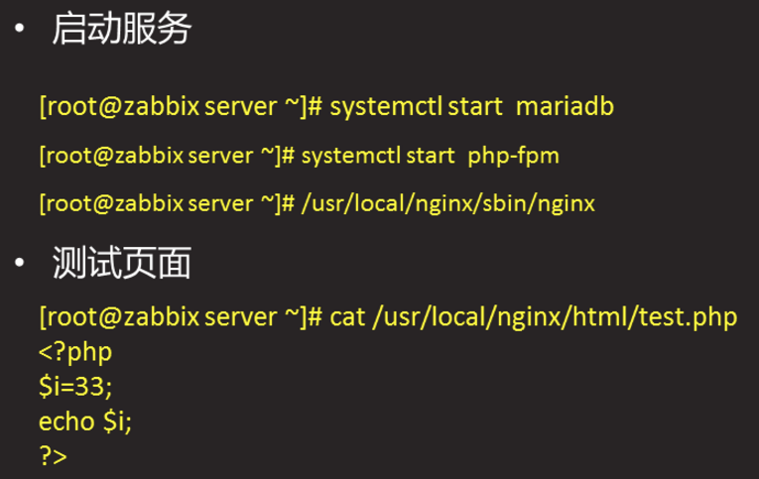

[root@zabbixserver ~]# systemctl restart mariadb

[root@zabbixserver ~]# systemctl enable mariadb

[root@zabbixserver ~]# systemctl restart php-fpm

[root@zabbixserver ~]# systemctl enable php-fpm

[root@zabbixserver ~]# nginx

[root@zabbixserver ~]# ss -nutlp | grep :3306

tcp LISTEN 0 50 *:3306 *:* users:(("mysqld",pid=26043,fd=14))

[root@zabbixserver ~]# ss -nutlp | grep :80

tcp LISTEN 0 128 *:80 *:* users:(("nginx",pid=26125,fd=6),("nginx",pid=26124,fd=6))

[root@zabbixserver ~]# ss -nutlp | grep :9000

tcp LISTEN 0 128 127.0.0.1:9000 *:* users:(("php-fpm",pid=26106,fd=0),("php-fpm",pid=26105,fd=0),("php-fpm",pid=26104,fd=0),("php-fpm",pid=26103,fd=0),("php-fpm",pid=26102,fd=0),("php-fpm",pid=26100,fd=6))

[root@zabbixserver ~]# curl http://localhost/test.php

33

安装zabbix

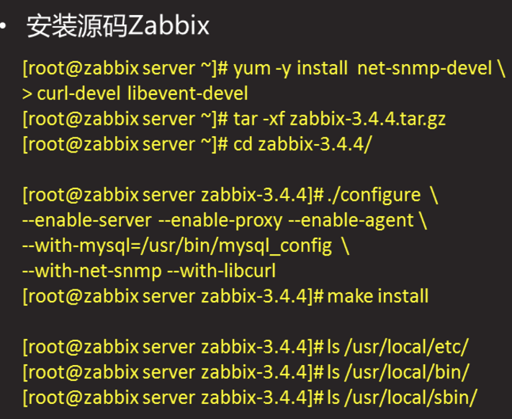

[root@zabbixserver zabbix-3.4.4]# yum -y install net-snmp-devel curl-devel libevent-devel

[root@zabbixserver zabbix-3.4.4]# tar -xf zabbix-3.4.4.tar.gz

[root@zabbixserver zabbix-3.4.4]# cd zabbix-3.4.4/

[root@zabbixserver zabbix-3.4.4]# ./configure --enable-server --enable-proxy --enable-agent --with-mysql=/usr/bin/mysql_config --with-net-snmp --with-libcurl

[root@zabbixserver zabbix-3.4.4]# make install

[root@zabbixserver zabbix-3.4.4]# ls /usr/local/etc/

zabbix_agentd.conf zabbix_proxy.conf zabbix_server.conf

zabbix_agentd.conf.d zabbix_proxy.conf.d zabbix_server.conf.d

[root@zabbixserver zabbix-3.4.4]# ls /usr/local/bin/

eip setip zabbix_get zabbix_sender

[root@zabbixserver zabbix-3.4.4]# ls /usr/local/sbin/

zabbix_agentd zabbix_proxy zabbix_server

初始化准备

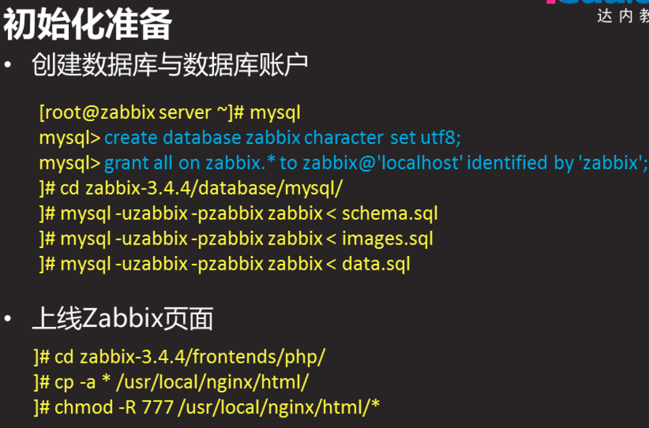

[root@zabbixserver ~]# mysql

MariaDB [(none)]> create database zabbix character set utf8;

MariaDB [(none)]> grant all on zabbix.* to zabbix@'localhost' identified by "zabbix";

MariaDB [(none)]> exit

[root@zabbixserver ~]# ls /root/Zabbix/zabbix-3.4.4/database/mysql/

data.sql images.sql schema.sql

[root@zabbixserver ~]# cd /root/Zabbix/zabbix-3.4.4/database/mysql/

[root@zabbixserver mysql]# mysql -uzabbix -pzabbix zabbix < schema.sql

[root@zabbixserver mysql]# mysql -uzabbix -pzabbix zabbix < images.sql

[root@zabbixserver mysql]# mysql -uzabbix -pzabbix zabbix < data.sq

//导入数据有先后顺序

上线页面

[root@zabbixserver]# cd /root/Zabbix/zabbix-3.4.4/frontends/php/

[root@zabbixserver php]# cp -a * /usr/local/nginx/html/

[root@zabbixserver php]# chmod -R 777 /usr/local/nginx/html/*

修改nginx的配置

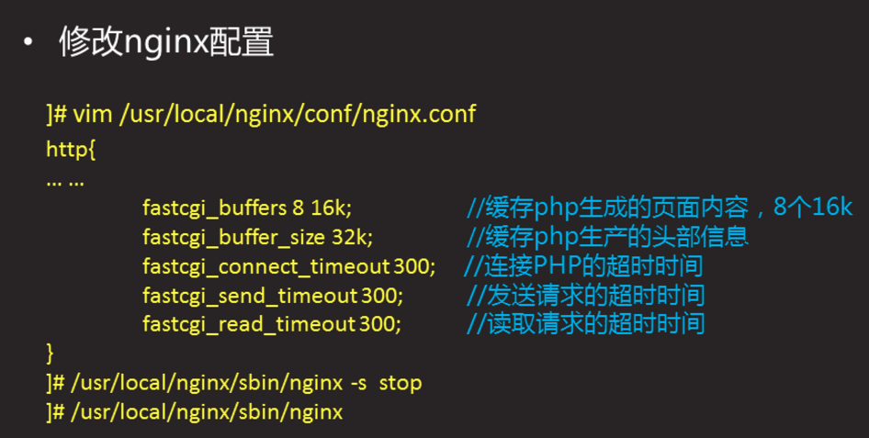

[root@zabbixserver php]# vim /usr/local/nginx/conf/nginx.conf

17 http {

18 fastcgi_buffers 8 16k;

19 fastcgi_buffer_size 32k;

20 fastcgi_connect_timeout 300;

21 fastcgi_send_timeout 300;

22 fastcgi_read_timeout 300;

[root@zabbixserver php]# nginx -s stop

[root@zabbixserver php]# nginx

安装依赖包,修改php配置文件

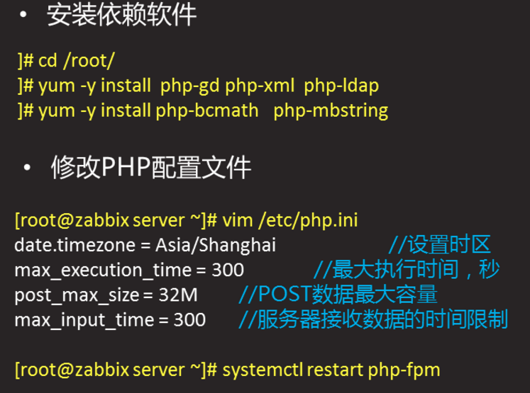

[root@zabbixserver ~]# yum -y install php-gd php-xml php-ldap

[root@zabbixserver ~]# yum -y install php-bcmath php-mbstring

[root@zabbixserver ~]# vim /etc/php.ini

878 date.timezone = Asia/Shanghai

384 max_execution_time = 300

394 max_input_time = 300

672 post_max_size = 32M

[root@zabbixserver ~]# systemctl restart php-fpm

zabbix页面初始化

[root@zabbixserver ~]# firefox http://192.168.2.5/index.php

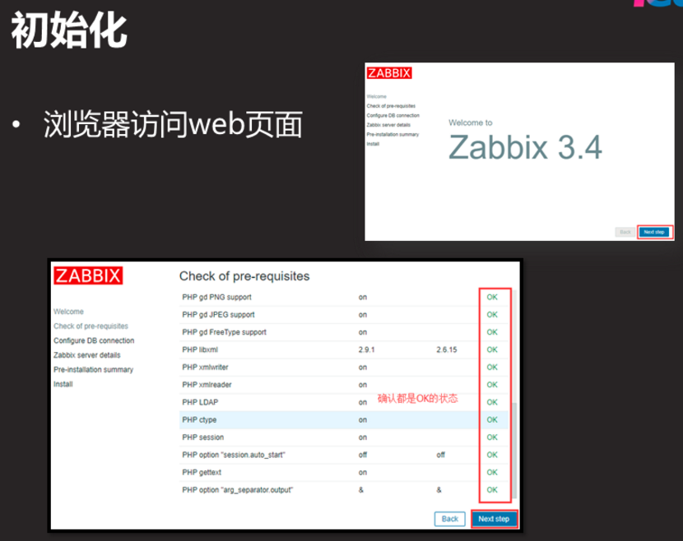

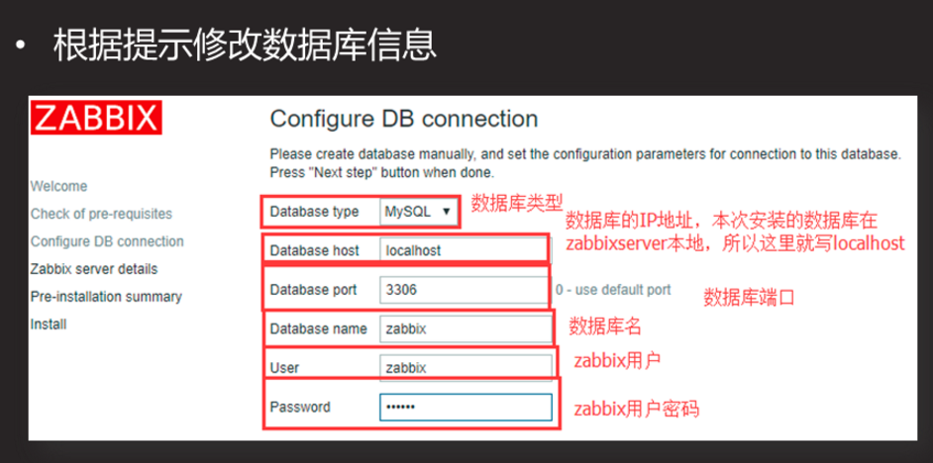

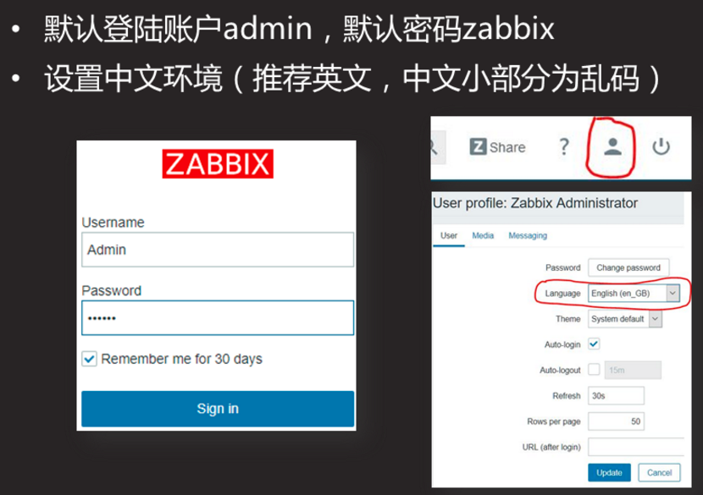

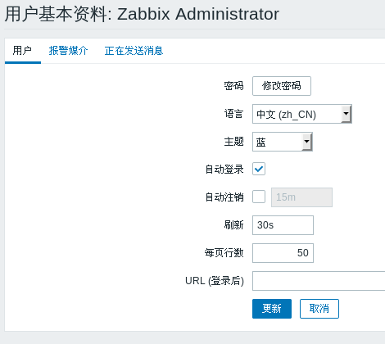

修改页面语言为中文

修改管理员登录密码

页面登录的修改文件

[root@zabbixserver ~]# cat /usr/local/nginx/html/conf/zabbix.conf.php

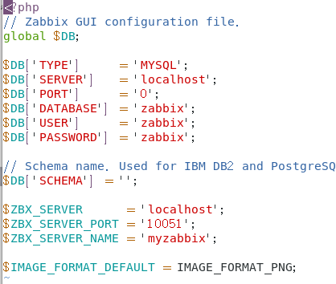

启动监控服务

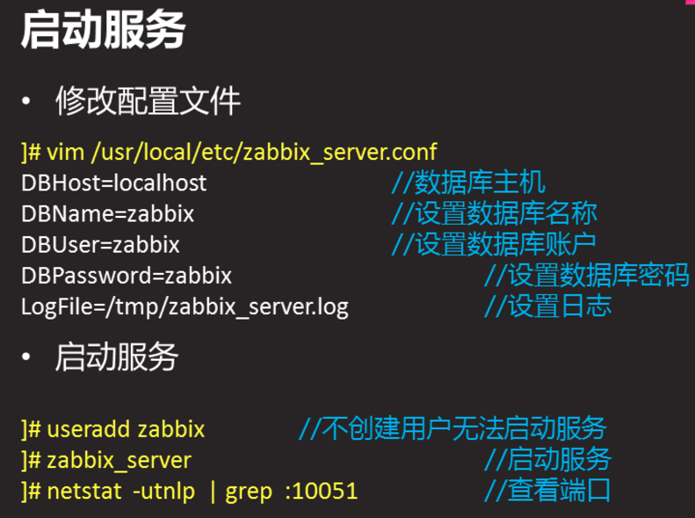

[root@zabbixserver ~]# vim /usr/local/etc/zabbix_server.conf

38 LogFile=/tmp/zabbix_server.log

85 DBHost=localhost

95 DBName=zabbix

111 DBUser=zabbix

119 DBPassword=zabbix

[root@zabbixserver ~]# useradd zabbix

[root@zabbixserver ~]# zabbix_server

[root@zabbixserver ~]# ss -ntlp | grep zabbix

LISTEN 0 128 *:10051 *:*

起不来查看日志文件

二Zabbix监控服务

2.1基础监控

配置被监控端

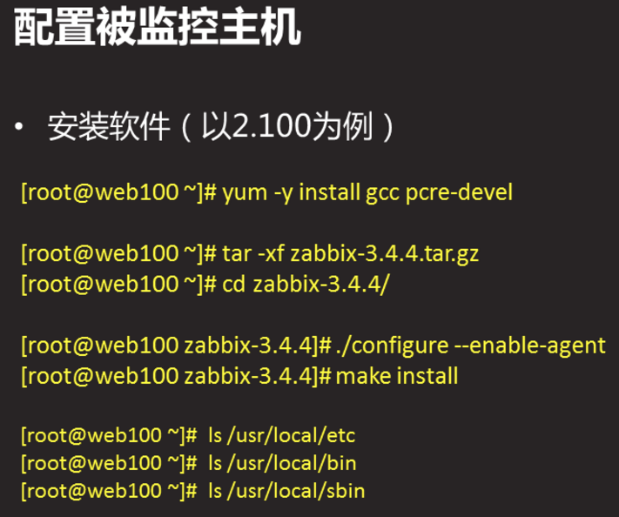

Web1机

[root@web1 Zabbix]# yum -y install gcc pcre-devel

[root@web1 ~]# cd /root/Zabbix/

[root@web1 Zabbix]# tar -xf zabbix-3.4.4.tar.gz

[root@web1 zabbix-3.4.4]# cd zabbix-3.4.4/

[root@web1 zabbix-3.4.4]# ./configure --enable-agent

[root@web1 zabbix-3.4.4]# make install

[root@web1 zabbix-3.4.4]# ls /usr/local/etc/

zabbix_agentd.conf zabbix_agentd.conf.d

[root@web1 zabbix-3.4.4]# ls /usr/local/bin/

eip setip zabbix_get zabbix_sender

[root@web1 zabbix-3.4.4]# ls /usr/local/sbin/

zabbix_agentd

修改配置文件

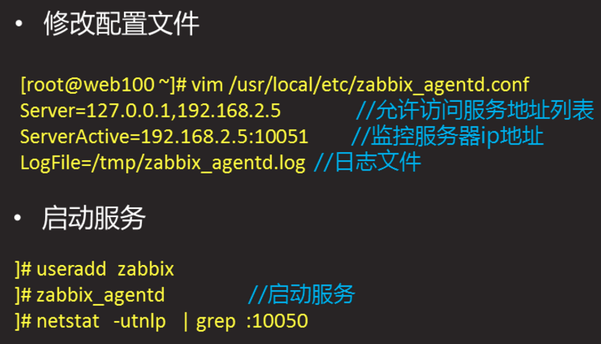

[root@web1 ~]# vim /usr/local/etc/zabbix_agentd.conf

30 LogFile=/tmp/zabbix_agentd.log

93 Server=127.0.0.1, 192.168.2.5

134 ServerActive=192.168.2.5:10051

[root@web1 ~]# useradd zabbix

[root@web1 ~]# zabbix_agentd

[root@web1 ~]# ss -nutlp |grep agentd

tcp LISTEN 0 128 *:10050 *:*

添加监控主机

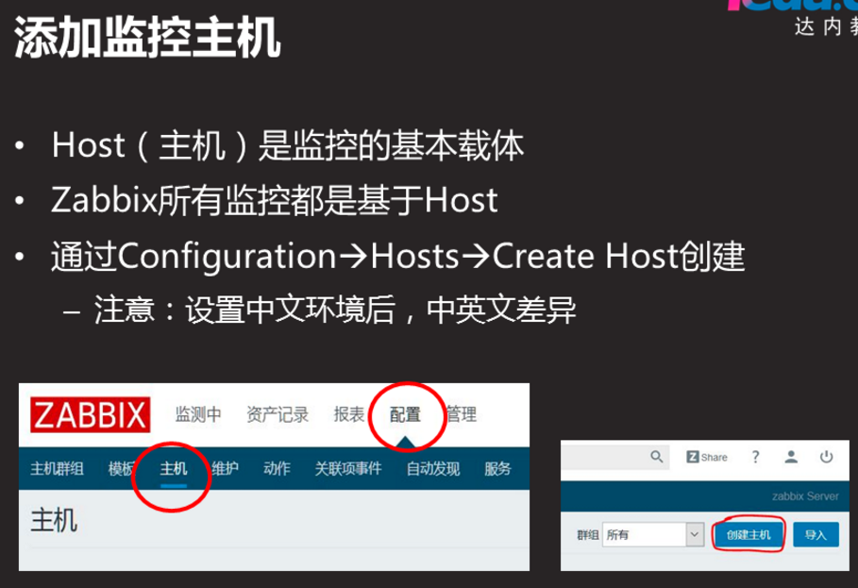

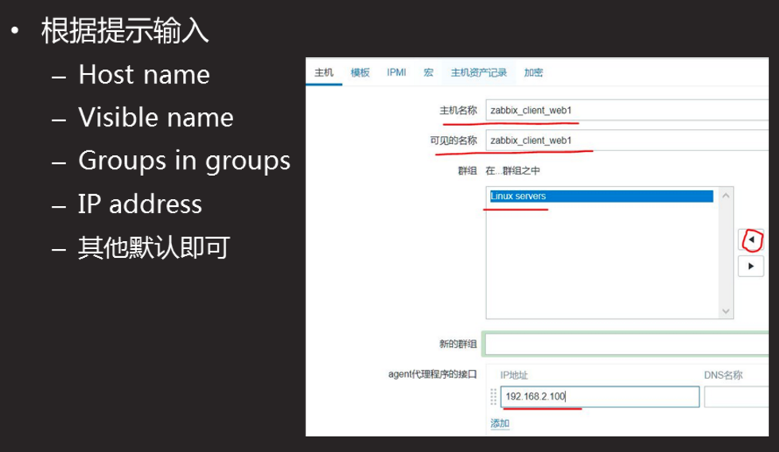

选择模板

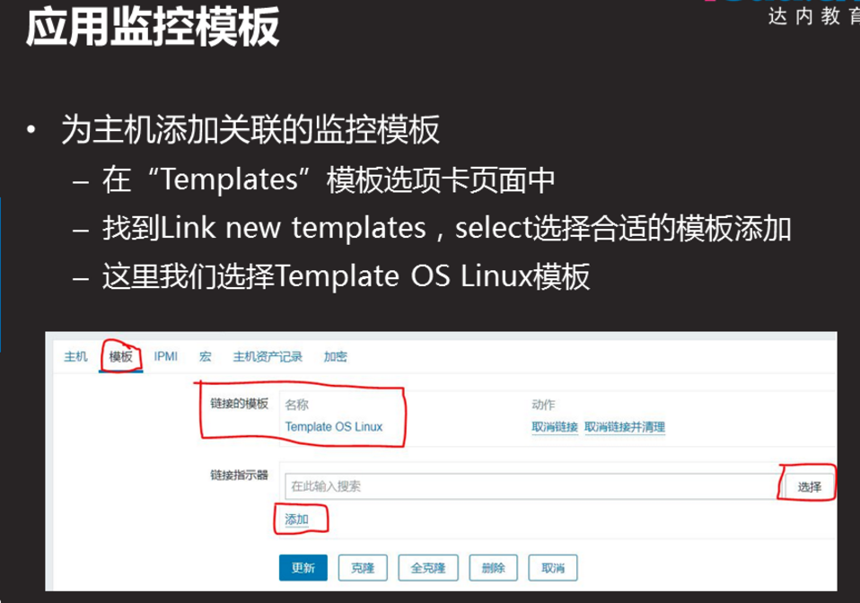

查看监控数据

查看监控数据

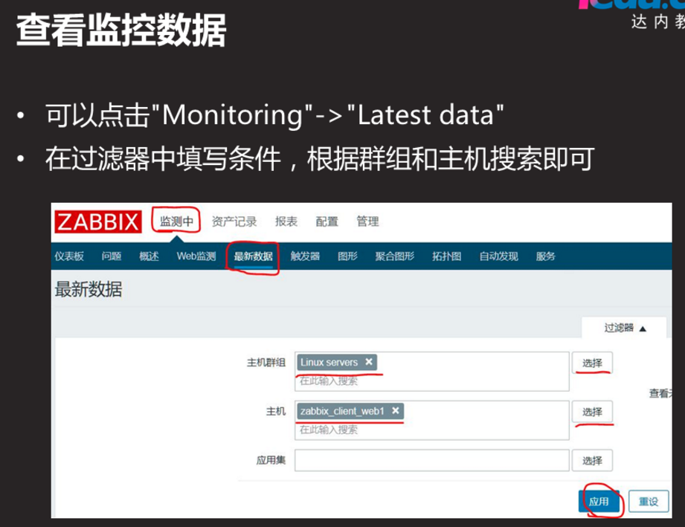

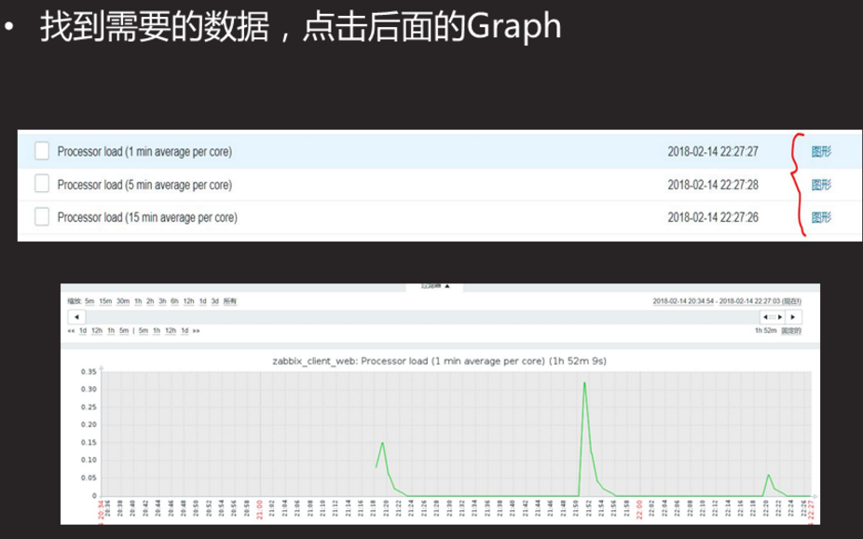

自定义监控项

客户端定义监控命令给监控服务器使用

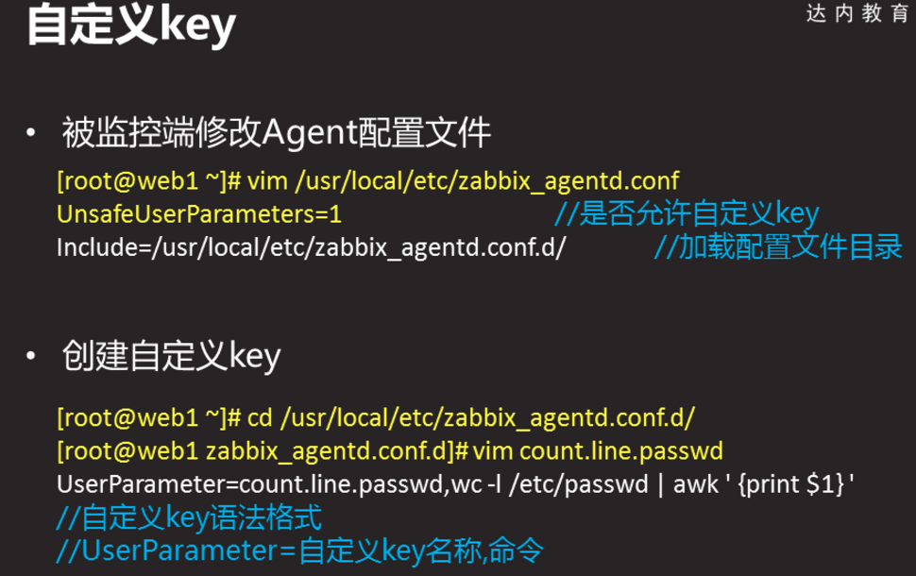

Web1机

[root@web1 ~]# vim /usr/local/etc/zabbix_agentd.conf

280 UnsafeUserParameters=1 //启用自定义

284 # Format: UserParameter=<key>,<shell command>

//自定义文件格式

265 Include=/usr/local/etc/zabbix_agentd.conf.d/*.conf //自定义文件存放的路径

[root@web1 ~]# vim /usr/local/etc/zabbix_agentd.conf.d/a.conf

UserParameter=a,wc -l /etc/passwd | awk '{print $1}'

[root@web1 ~]# killall -9 zabbix_agentd

[root@web1 ~]# zabbix_agentd

[root@web1 ~]# zabbix_get -s 127.0.0.1 -p 10050 -k a

配置监控服务器

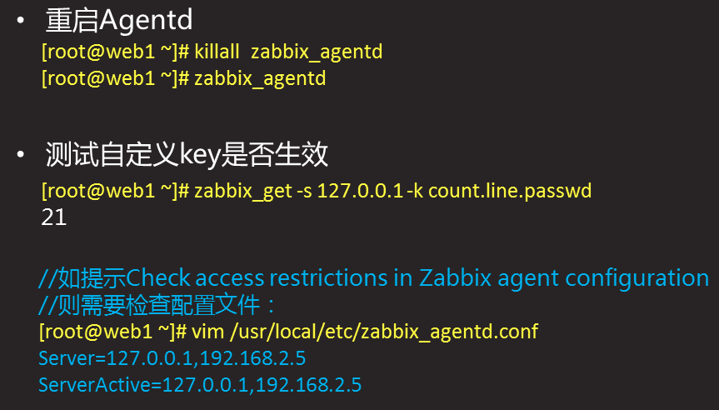

创建自定义监控模板

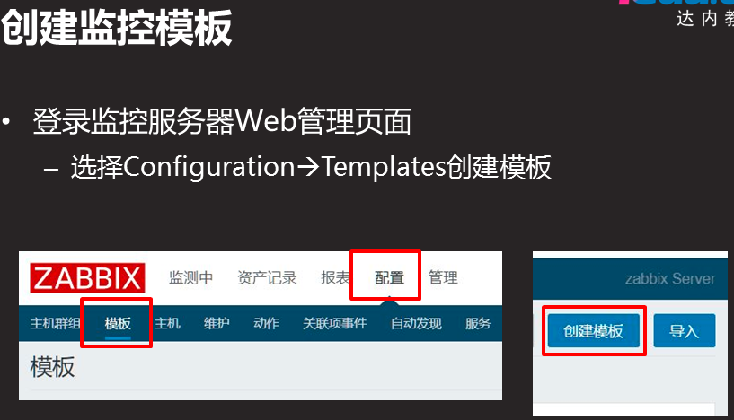

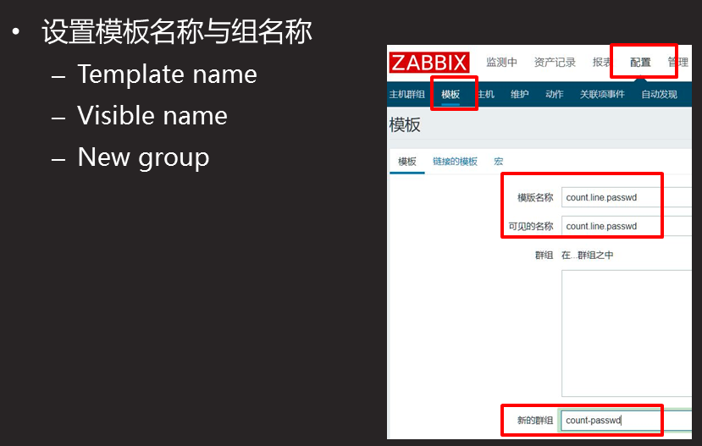

创建应用

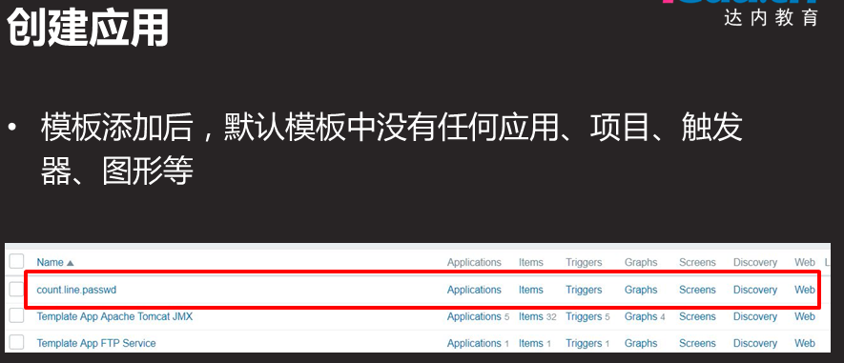

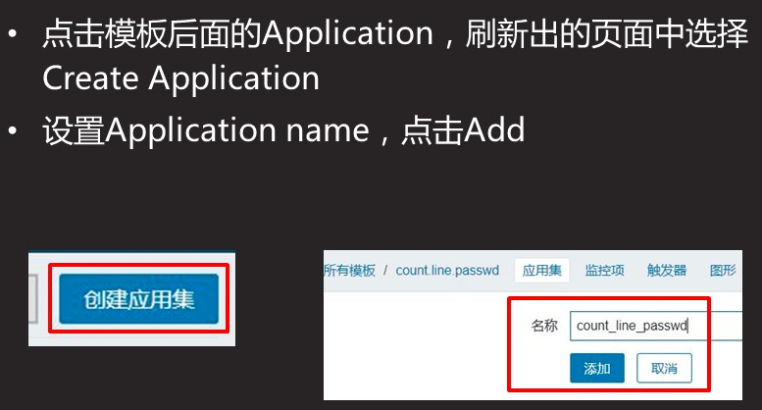

创建监控目录

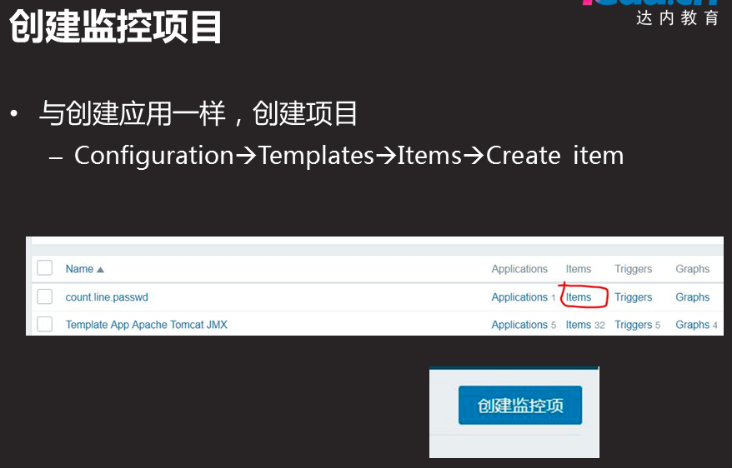

2019-07-25 11-41-10 的屏幕截图

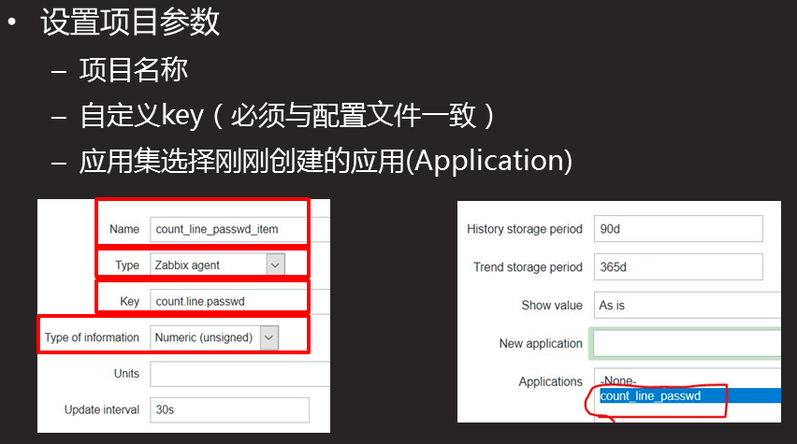

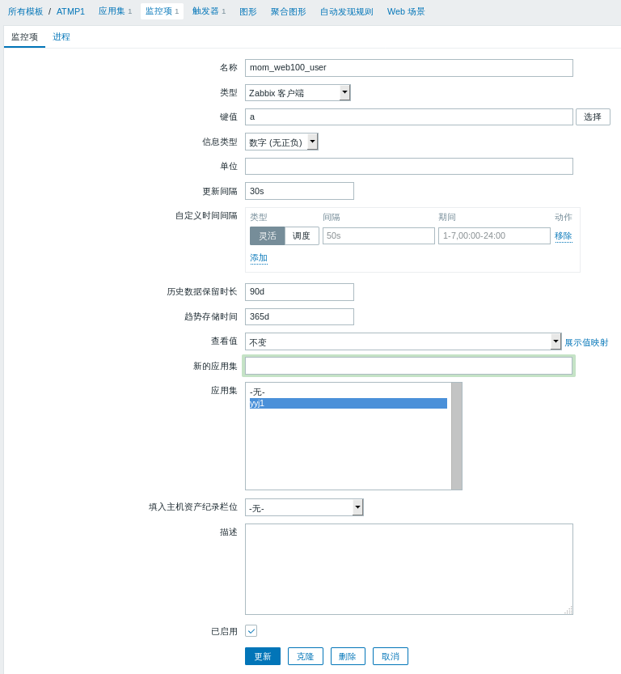

创建图形

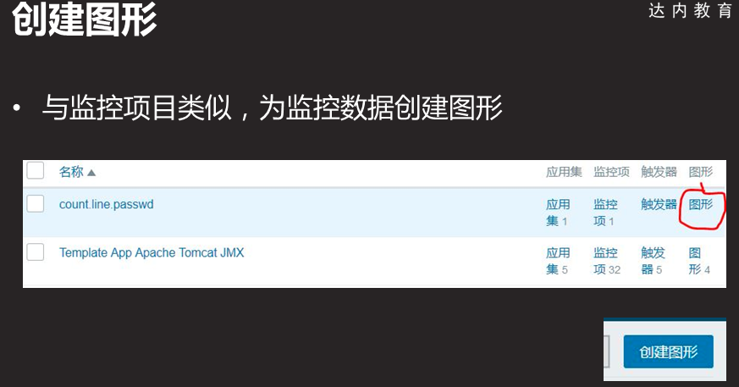

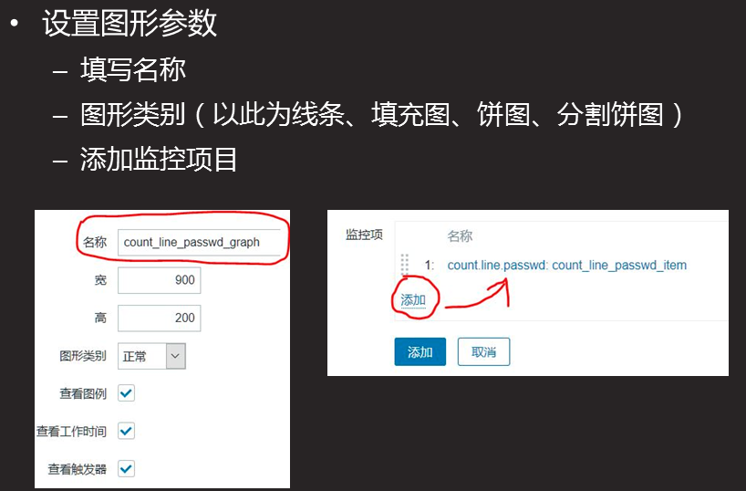

将模板与主机关联

